The PF Crisis Guide

The Pass/Fail Crisis Guide
Drafted by the Policy and Resources Department of
Ministry of Academic Affairs 2024-25
Date of Completion of Draft: 01/03/25

Disclaimer

This document serves as a general guide to help students navigate the Pass/Fail (P/F) option. As individual circumstances vary, students are encouraged to carefully assess all relevant factors before making a decision. These are suggestions collected from over 50 students from various departments and batches regarding their experience and curated by the MAA. It is not an official policy, and the MAA is not responsible for any outcomes resulting from their application. Please consider the information thoughtfully and make an informed choice based on your own academic needs.
Drafting credits: Dhruv Jain, Mehati Punamaraju, Minal Priya, Navvya Rahate & Umang Chauhan.

Introduction

The Pass/Fail (P/F) policy permits students from the UG 2023 (intake) and prior batches to take Major/Minor/Concentration/other, and FC (including ICT) courses, excluding ISMs and Capstone Thesis, without the pressure of letter grades affecting their GPA. Instead of a standard grade, students receive a P (Pass) or F (Fail), with a P indicating satisfactory completion. This option has been discontinued for the 2024-28 batch. Please read the P/F for internship policy for UG2024 from the General Policy Document by MAA. Students may utilize the P/F option for a maximum of 8 credits over three years and 4 credits in the fourth year/ASP25. The deadline to opt for P/F is Week 8 of a regular semester and Week 4 of the summer semester, with the Spring 2025 deadline set for March 16, 2025 (11:55 pm).

Please feel free to refer to the following for more details:
Ashoka Official Handbook about Pass/Fail Grading System [Please note that this is an OAA document and MAA does not take responsibility for its updated status. We suggest you speak with them or with our team if you find any discrepancies between the information mentioned here and in our general policy document.]
MAA General Academic Policies Document

Key Considerations for P/F Decision [Based on Responses from Student Body]

General Factors

- Grading Structure & Clarity
Absolute vs. relative grading: Courses with absolute grading use fixed percentage cutoffs, while relative grading depends on class performance. In relative grading, compare your standing to the cohort—if the class scores high, securing a top grade may be harder; if it scores low, the curve may work in your favor. Some students reported uncertainty about their relative standing before the P/F deadline, making the decision more difficult.
Rubric transparency: A well-defined grading rubric helps set expectations and provides insight into how your work will be assessed. If grading criteria are vague, inconsistently applied, or past students have reported unpredictable grading patterns, opting for P/F might be a safer choice.
Midterm format clarity: A well-structured midterm allows for accurate self-assessment. If the format is ambiguous or inconsistent, P/F could help reduce uncertainty.
Past grading trends: If the course is known for having low average grades or a high failure rate, P/F may be a strategic option to protect your GPA.
Course transparency issues: If the professor does not disclose grading structures or past trends until the end of the semester, the unpredictability may make P/F a safer option.
- Professor’s Teaching & Grading Style
Strict vs. lenient grading patterns: Some professors are known for strict grading, while others are more lenient. If a professor has a history of giving lower grades, opting for P/F may be advisable. Some students expressed concerns about harsh grading without clear justification.
Responsiveness & feedback quality: If the instructor provides clear explanations, structured coursework, and timely feedback, there may be opportunities to improve even after a poor initial performance.

- Semester Workload
Multiple difficult courses in the same semester: A heavy academic load can make it harder to manage the course. If several other courses require significant effort, opting for P/F may help distribute your workload more efficiently. Many students cited using P/F to balance commitments across multiple demanding courses.
Courses with Heavy Workloads: If a course has a particularly heavy workload, challenging material, or a rigorous assessment structure, opting for P/F can help alleviate academic pressure. However, if you are confident in managing the difficulty and believe consistent effort will result in a strong grade, retaining the letter grade may be the better choice.
- Well-Being Considerations
Stress management: If a course is significantly impacting your mental health or overall stress levels, opting for P/F may help reduce pressure and allow you to focus on other responsibilities.
Burnout prevention: If you are juggling multiple demanding courses, internships, or extracurricular commitments, taking a P/F can help prevent burnout and maintain a sustainable workload.
Motivation & engagement: Some students find that taking a course as P/F reduces their motivation to engage with the material. If external accountability helps you stay committed, keeping the letter grade might be the better choice.

If Midterm Was Before the P/F Deadline:
- Performance in the midterm: If you performed significantly worse than expected, P/F may help prevent a low grade from negatively affecting your GPA. However, if your performance aligns with or exceeds expectations, keeping the letter grade may be beneficial.
- Weightage of midterm in final grade: If the midterm constitutes a large percentage of the final grade, its impact on your course outcome is significant. Poor performance in a high-weightage midterm could justify opting for P/F. Some students regretted taking P/F too early when later assessments improved their overall standing.

If Midterm Was On or After the P/F Deadline:
- Early assessments before the midterm: If there have been quizzes or assignments before the midterm, they can help predict final performance.
  - If no assessments have been conducted, consult the TF or professor to discuss your concerns and gain their insights. Additionally, prioritize other factors with available reference points for a more informed decision.
- Weightage of final assessments: Without midterm grades, evaluating the weightage of final assessments is crucial. If the final exam or project constitutes a large portion of the grade and you are confident in your ability to improve, keeping the letter grade may be feasible. If not, P/F may be a viable choice.

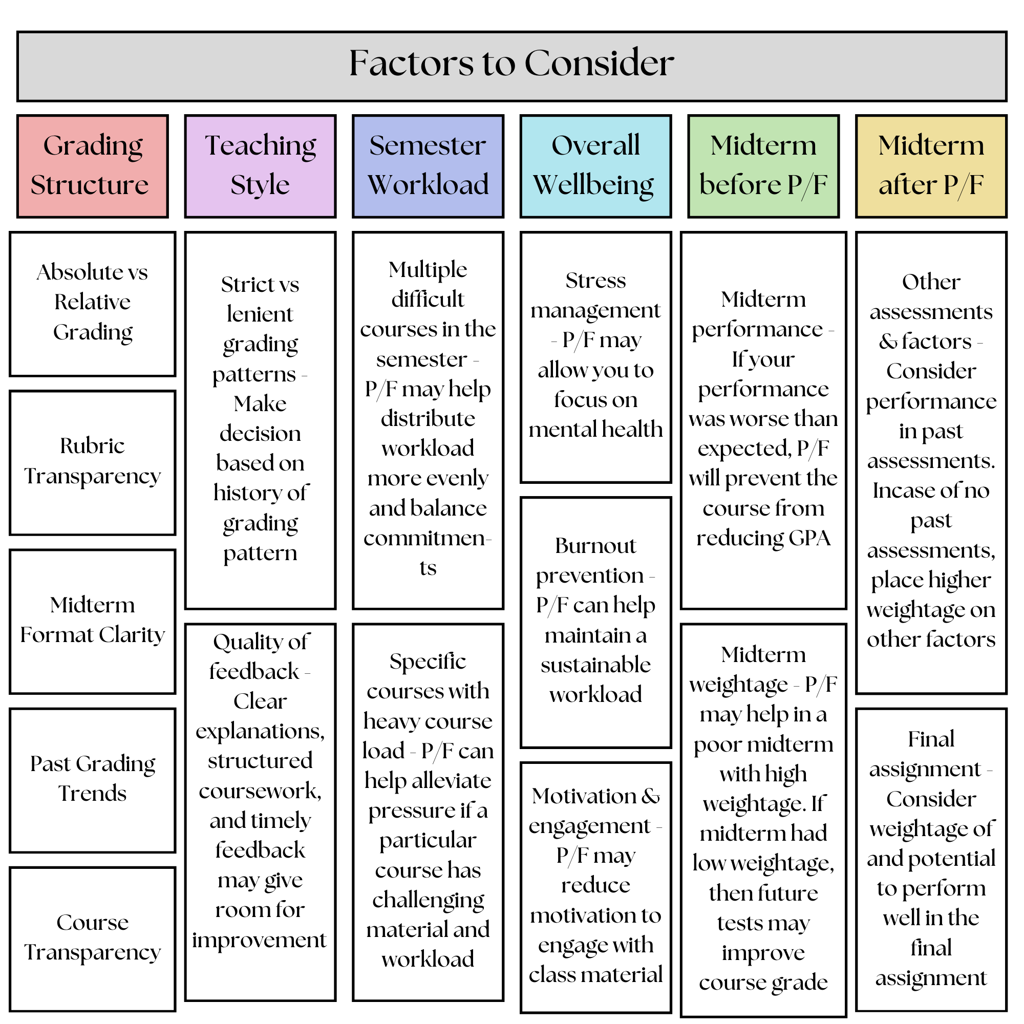

Department-Specific Considerations for P/F Decisions
While the general factors for opting for Pass/Fail apply across all courses, student responses indicate that certain considerations are more relevant in specific departments. The following insights highlight common patterns in how students have made P/F decisions based on their academic field.
Computer Science (CS)
- Some students found course structures unclear and grading criteria difficult to understand.
- Responsiveness from professors and TFs varied, making it challenging to seek clarifications.
- In certain cases, grading structures were not disclosed until later in the semester.
- Some students opted for P/F as a precaution, even when their final grades turned out better than expected.
More Relevant Factors:
- A lack of grading transparency made it difficult to predict outcomes.
- In courses where many students chose P/F, the decision seemed influenced by course structure rather than individual performance.
Economics & Finance
- Some students found math-intensive courses like Microeconomic Theory and Econometrics particularly challenging.
- Delayed feedback led to uncertainty about performance before the P/F deadline.
- A few students later realized they could have secured a better grade, leading to mixed feelings about their decision.
More Relevant Factors:
- Some students took the difficulty level of certain courses into account when deciding on P/F.
- A few relied on past grading trends when making their decision, particularly in courses known for lower average grades.
Mathematics
- Many courses placed significant weight on final exams, which meant fewer early assessments to assess one’s performance.
- A few students found that their experience in the course was influenced by the professor’s teaching style.
- Some students opted for P/F due to difficulty balancing multiple quantitative courses in the same semester.
More Relevant Factors:
- In courses with heavily weighted final exams, students had limited data to assess their standing before the P/F deadline.
- Some students factored in the clarity of teaching and grading expectations when making their decision.
- Students also took into consideration their semester workload.
Political Science, International Relations, and History
- Some students found grading to be subjective, making it harder to predict final outcomes.
- A lack of structured feedback before the P/F deadline contributed to uncertainty.
- Some students considered opting for P/F more due to course difficulty rather than concerns about GPA.
More Relevant Factors:
- The subjectivity of grading in essay-based courses played a role in decision-making.
- Some students found that not receiving early feedback on assignments made it harder to judge their performance.
Psychology
- Some students found it challenging to balance coursework with other academic commitments.
- A few later felt that they could have kept the letter grade, as their final performance exceeded initial expectations.
- In some cases, limited feedback before the deadline made it difficult to make an informed decision.
More Relevant Factors:
- Some students considered workload balance across multiple demanding courses.
- Courses with early assessments provided more clarity, while those without made P/F decisions more uncertain.
Sociology & Anthropology (SOA)
- A few students found that the heavy reading load influenced their decision to opt for P/F.
- Some mentioned that grading rubrics were not always detailed, making it harder to evaluate performance.
- In certain cases, students received feedback later in the semester, which led to uncertainty before the deadline.

Frequently Asked Questions (FAQs)
- Which courses are eligible for the P/F policy?
  - The P/F policy applies to major and minor courses, Foundation Courses (FCs, including ICT), and Critical Thinking Seminars (CTS). However, it is not available for Independent Study Modules (ISMs) or Capstone-related courses.
- When is the deadline to opt for P/F grading?
  - Students can switch from letter grading to P/F by the end of the 8th week in the spring/monsoon semester and the end of the 4th week in the summer semester. For Spring 2025, the deadline is March 16.
- How many credits can be taken under the P/F policy?
  - UG students (3-year program): Up to 8 credits
  - ASP students (for ASP25)/ UG students (4-year program): Additional 4 credits (Total 12 credits)
- How many courses can be taken as P/F in a single semester?
  - Students can apply the P/F policy to only one course per semester.
- Can a course with a P grade be retaken?
  - No, a course that has been completed with a P grade cannot be retaken.
- Can a course with letter grading be retaken as P/F?
  - Yes, a course initially taken for a letter grade may be retaken as P/F. If passed, the P grade will replace the previous letter grade in credit calculations.
- What letter grades are converted to P and F?
  - P (Pass): A to D-
  - F (Fail): F
- How are P/F grades assigned?
  - Instructors submit letter grades, which the Office of Academic Affairs (OAA) then converts to P or F based on the grading criteria.
- Does a P grade affect my GPA?
  - No, a P grade does not impact GPA and is not included in CGPA calculations. However, an F grade affects the GPA as usual.
- Does a P-graded course count toward credit and prerequisite requirements?
  - Yes, a course with a P grade counts toward both credit requirements and prerequisites.
- Does taking a P grade affect eligibility for academic honors?
  - Dean’s List: Students are not eligible for the Dean’s List in a semester where they have taken a P grade.
  - Latin Honours: Semesters with P grades count towards eligibility, but only courses with letter grades contribute to the final honors calculation.

Please reach out to MAA in case of any more queries or concerns.

